**Pdb file:**

We got from our client some pdb files she nowadays sends to get the simulations.

She downloads those filee from this website: https://www.rcsb.org/

If we open those files with a text editor, we will see list of all atoms:

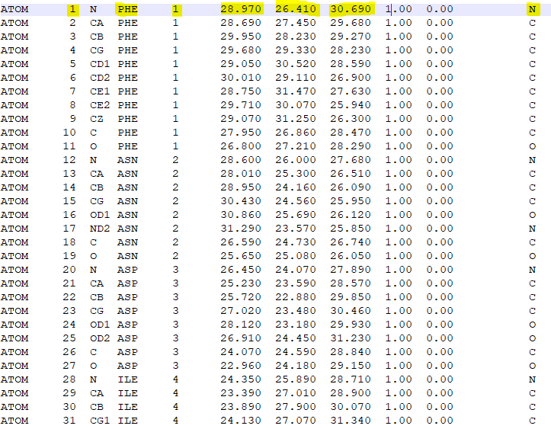

Now we will discuses about the list structure and more important – what we should extract in order to use the algorithm we chose.

For each atom we can see:

His number in the protein , the name of the amino acid he is part of(we can see that all atoms in the same amino acid are mark with the same number in the fifth column),x coordinate ,y coordinate , z coordinate and in the last column we can see the atom's symbol.

Elizabeth Yeshaayahu